**GAME DEVELOPMENT (COMP3540 / COMP6540)**

**DEVELOPER DIARY ENTRY**

|  |  |
| --- | --- |
| UID: | Name: Lingxiu Cai |
| Diary: *5* | Week: *12* |

*All word limits are maximums – do not exceed them. Only write what you need.*

**Work Log**

*Log the hours you worked and details of tasks you have completed. List one task per row and add rows as necessary. These are tasks that you personally completed, or your personal contribution to group tasks. Each task should have at least one piece of associated evidence (see Work Evidence). (No word limit, but be concise).*

|  |  |
| --- | --- |
| **Task Description** | **Date/Time worked** |
| Merge Branches: (Figure 1)  Collaborated with team members to merge individual development branches. Identified and rectified integration bugs that arose post-merge, ensuring smooth functionality. | 10/22 20:00 ~ 22:00  10/26 13:00 ~ 15:00 |
| Personal Game development work 1: (Figure 2, 3, 4, 5)  Reviewed all clues in the game, standardizing their formats for consistency. Refined clue details to enhance player understanding and game immersion. | 10/26 17:00 ~ 19:00 |
| Personal Game development work 2: (Figure 6, 7, 8)  Implemented a new gameplay clue located within the hidden room. Identified a bug that prevented players from accessing the hidden room post-puzzle completion and successfully addressed it. | 10/27 13:00 ~ 15:00 |
|  |  |

**Challenges/Questions**

*Identify and discuss any challenges or questions that you encountered in completing your tasks this week. (200 words maximum)*

|  |
| --- |
| During this week, one of the most significant challenges I faced was the integration of various branches from my teammates into the main codebase. Merging often presents many unforeseen issues, and our team was not exempt from this. Ensuring everyone's contributions seamlessly fit into the main project without conflicts or disruptions was a technical hurdle. The merged code resulted in a few unexpected bugs, which took substantial time and collaboration to pinpoint and resolve.  Another challenge arose when standardizing the format of the game clues. The task required not only a keen attention to detail but also a deep understanding of each clue's context within the game. Striking a balance between uniformity in presentation and maintaining the unique essence of each clue was trickier than expected.  Lastly, on a personal development front, adding a new clue in the hidden room brought about its set of complexities. Addressing the bug that prevented players from entering the room post-puzzle was an issue. The challenge lay in ensuring that the solution did not compromise other established game mechanics or hinder the player's experience.  Navigating these challenges required teamwork, constant communication, and a willingness to delve back into work, reevaluate, and iterate for better outcomes. |

**Strategies/Learnings**

*Identify and discuss the strategies you used to solve challenges, answer questions, and what you learned. (200 words maximum)*

|  |
| --- |
| Our team employed a collaborative debugging approach to address the challenges faced during the merging process. Instead of attempting to solve problems individually, we held a joint session, which proved invaluable. By pooling our collective knowledge and expertise, we were able to troubleshoot and resolve the arising issues post-merge efficiently.  In standardizing the format of the game clues, a shared document was utilized to gather all clues in one place, allowing for a bird's-eye view of the content. This made it easier to identify inconsistencies and streamline the formatting process. I learned the importance of having a unified style guide early on to prevent such challenges in future projects.  For the personal development task, I adopted a systematic problem-solving approach. I started by consistently isolating the issue, replicating the bug, and methodically testing potential solutions. This iterative process helped narrow the root cause and eventually solve the issue. From this, I learned the value of patience and persistence when tackling game development bugs.  Overall, these challenges emphasized the importance of effective team communication, the benefits of a centralized documentation system, and the necessity of systematic troubleshooting in game development. The experiences have provided insights that will undoubtedly aid in future projects. |

**Work Evidence**

*Demonstrate the work you have completed (sketches, links, code).* *Any evidence added here should be numbered and referenced in the Work Log table above. Each task should have at least one piece of evidence.*

**Figure 1: Merge branches.**

**Figure 2: Standardize the format of Fallen glass clue.**

**Figure 3: Standardize the format of Dead body clue and add background information.**

**Figure 4: Standardize the format of Dairy clue and add background story.**

**Figure 5: Standardize the format of clue bag clue.**

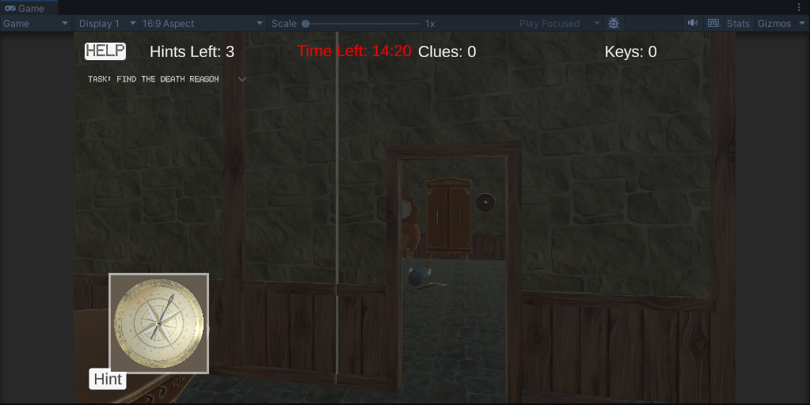

**Figure 6: Fixed the problem of player can't enter the hidden room.**

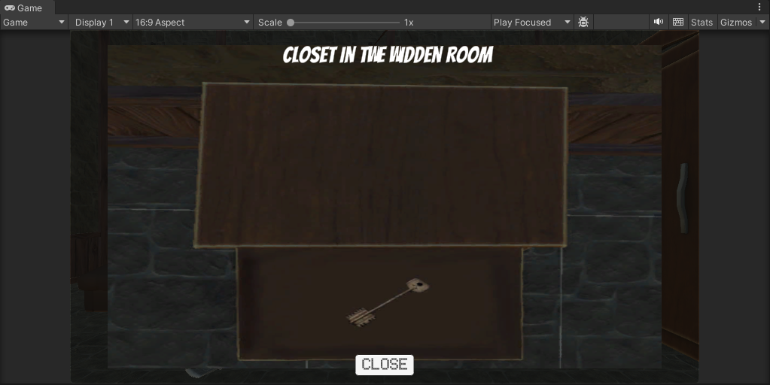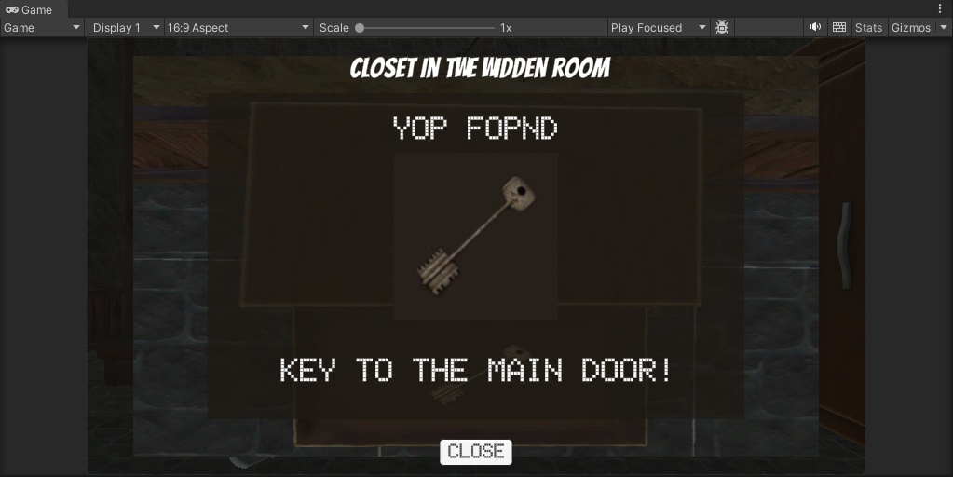

**Figure 7, 8: New clue added.**